**DREAMLAND HIGH SCHOOL NAMULANDA**

**COMPETENCY BASED CURRICULUM-CBC**

**END OF YEAR ASSESSMENT 2023**

**SENIOR THREE**

**GEOGRAPHY**

**Time allowed: 2 hour 30 minutes**

***Instructions***

***Section A*** *is compulsory*

*Attempt* ***four*** *questions in total*

***MAP WORK (20 MARKS)***

1. Carefully study the map of **Bulisa,** part of sheet **29/4 series Y732** and do the tasks that follow;
2. State the grid reference of a borehole north of kibambura. (score 1)
3. What feature is found on grid reference 296373 (score 1)
4. John is visiting Bulisa for the first time. He is going to Lake Albert using public transport and entering Bulisa area from the south via butiaba and Masindi loose surface road.
5. How much distance will he travel in kilometres along that road to reach the shores of Lake Albert? (score 1)
6. If the cost of travelling by taxi on the road is UGX 5,000 per kilometre, how much will he pay to travel by taxi on the loose surface road from Bulisa road junction to Butiaba & Masindi. (score 5)
7. He intends to tour Lake Albert, but has very little knowledge about how large it is. Help him determine the area covered by Lake Albert ***excluding swamps***.

(Score 5)

1. He intends to attend a church service at the church at Kisansya (Grid reference 231376) before visiting the trigonometrical station at katara (gride reference 208344). Help him to determine the:

* Direction in which he will move from the church to the trigonometrical station (score 2)
* Bearing of the trigonometrical station from the church. (score 2)

1. With evidence from the area shown on the map, suggest three economic activities that can be carried out (score 3)
2. **FIELDWORK (20 MARKS)**

For any fieldwork study carried out as a group or individual;

1. State the;
2. Topic (score 2)
3. Objectives (score 2)
4. how did you prepare yourself for the actual fieldwork? (score 4)
5. How did you use the following methods of data collection;
6. Interviewing (score 4)
7. Observation (score 4)
8. As a geographer which practical skills did you gain from your study? (score 4)
9. Lake Bunyonyi is found in Kabale, a district in southwestern Uganda. It is surrounded by a hilly terraced landscape, which provided a scenic beauty to the sub region that has attracted many tourists to the area.

**Support material**

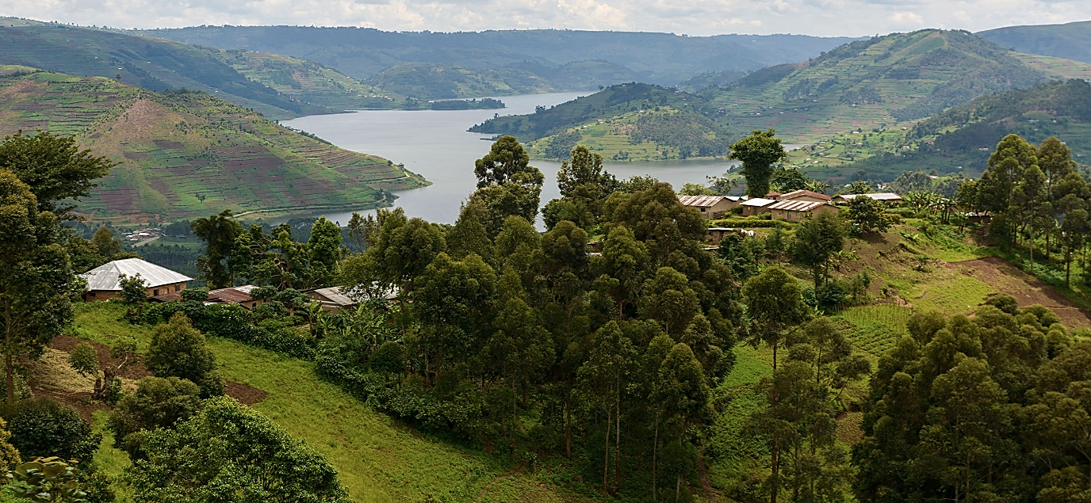

1. Draw a landscape sketch of the area shown in the support material and on it mark and name;
2. The lake, bays and headlands
3. The hilly landscape
4. The forest and settlement (7 scores)
5. (i) Explain four reasons why you would recommend a tourist coming to east Africa to visit the area shown in the photograph. (4 scores)

(ii) Mubiru Melisa a S.2 student of Entebbe bright sec school told classmates that her

parents are planning to migrate form this area in the photograph (Kabale) very soon.

In four statements, support the decision of melisa’s parents. (4 scores)

1. Describe the processes for the formation of either the **lake** or the **headland.** (5 scores)
2. (i) State any other **two** lakes in southwestern Uganda formed in a similar way like Lake

Bunyonyi. (2 scores)

(ii)This sub region has all the three types of rocks. State any **three** examples of igneous

rocks. (3 scores)

**SECTION B**

Attempt **one** question from this section

1. Study the table below showing data derived from one of the weather stations on the shores of Lake Victoria and answer the questions that follow.

|  |  |  |  |  |  |  |  |  |  |  |  |  |
| --- | --- | --- | --- | --- | --- | --- | --- | --- | --- | --- | --- | --- |
| Month | **J** | **F** | **M** | **A** | **M** | **J** | **J** | **A** | **S** | **O** | **N** | **D** |
| Temp (oC) | 20 | 21 | 22 | 22 | 21 | 20 | 20 | 21 | 22 | 22 | 21 | 20 |
| Rainfall (mm) | 30 | 40 | 128 | 195 | 190 | 40 | 54 | 98 | 130 | 218 | 145 | 37 |

1. Using the graph paper provided, neatly draw a climate graph to portray the above data. (9scores)
2. A group of local farmers in the area where the station is found, have just received funds from the government under the parish development model (PDM) scheme. They wish to carry out a farming project of growing crops.

Among the activities they are expected to do are; clearing the land, ploughing, preparation of seeds, planting, spraying, weeding.

As somebody who has learnt and understood the influence of climate on human activities, design **a farm calendar** to help these local farmers *plan*, *coordinate* and *effectively carry out farming activities* throughout the year (4score )

1. In your analysis, prove that you cannot support your friend to settle in such an area where this station is located. (5scores)
2. From the above table, determine the following;
3. Annual Range of Temperature. (2scores)
4. Mean Annual Rainfall. (2scores)
5. Mean Annual Temperature. (2scores)
6. The driest month (1score)
7. 90% households in Uganda derive their energy from firewood and charcoal. According to the world bank, the total demand for wood fuel is estimated to have increased by 9.1%between 2015- 2019. This has translated into massive acres of forests and woodlands being cleared for firewood and charcoal leading to climate change. *(source: The new vision Newspaper: February 19th 2023).*

*You have been appointed as a national programme officer for NEMA, write an article of about 100 words on the advices you will make to the ministry of environment to change the trend of the forest cover destruction.* (score 20)

1. 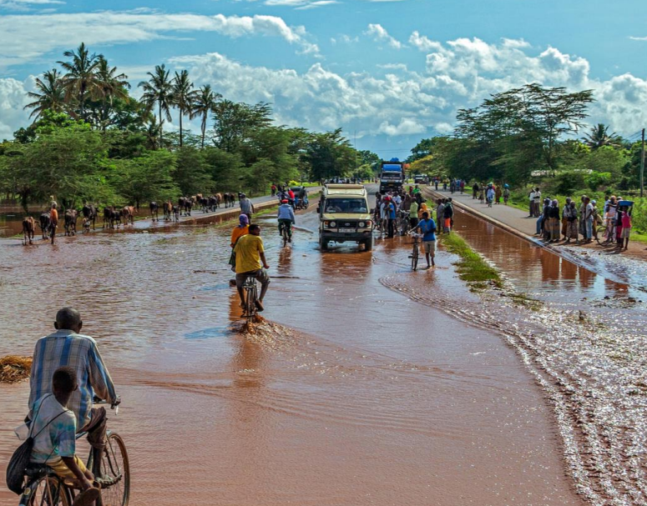You have watched on television that katonga river in may 2023 flooded over the area around and it affected many people’s lives and their property.

Write a letter to the ministry of disaster preparedness and refugees in Uganda advising them on what can be done before another natural disaster strikes people dead. In your letter indicate the causes of floods and their effects and possible solutions *(score 20)*

1. Write a speech of not more than 50 words about the topic ;**My Environment, My Responsibility**  *(score 20)*

**END**

**By TR.HASSAN K.**

**COMPETENCY BASED CURRICULUM-CBC**

**END OF YEAR ASSESSMENT 2023**

**SENIOR TWO**

**GEOGRAPHY**

**Time allowed: 2 hour 30 minutes**

***Instructions***

1. You have watched on television that katonga river in may 2023 flooded over the area around and it affected many people’s lives and their property.

Write a letter to the ministry of disaster preparedness and refugees in Uganda advising them on what can be done before another natural disaster strikes people dead. In your letter indicate the causes of floods and their effects and possible solutions *(20 marks)*

1. Write a speech of not more than 50 words about the topic ;**My Environment, My Responsibility**  *(15 marks)*
2. a) The ground floor of the building is 20X30 feets. Scale down the length and width of the building to fit on your paper. Clearly show the scale and draw a sketch of the building showing the length and the width (5 marks)